
Assignment 1
ADDB7311

September 5, 2024
ST10393280
Daniel Luke James

Table of Contents
Question 1 2
Question 2 3
Question 3 7
Q.3.1 7
Q.3.2 7
Question 4 8
Q.4.1 8
Q.4.2 8
Question 5 10
Q.5.1 10
Q.5.2 10
Q.5.3 10
Q.5.3.1 10
Q.5.3.2 11
Question 6 12
Q.6.1 12
Q.6.2 13
SQL Code 15
Reference List 33

Question 1
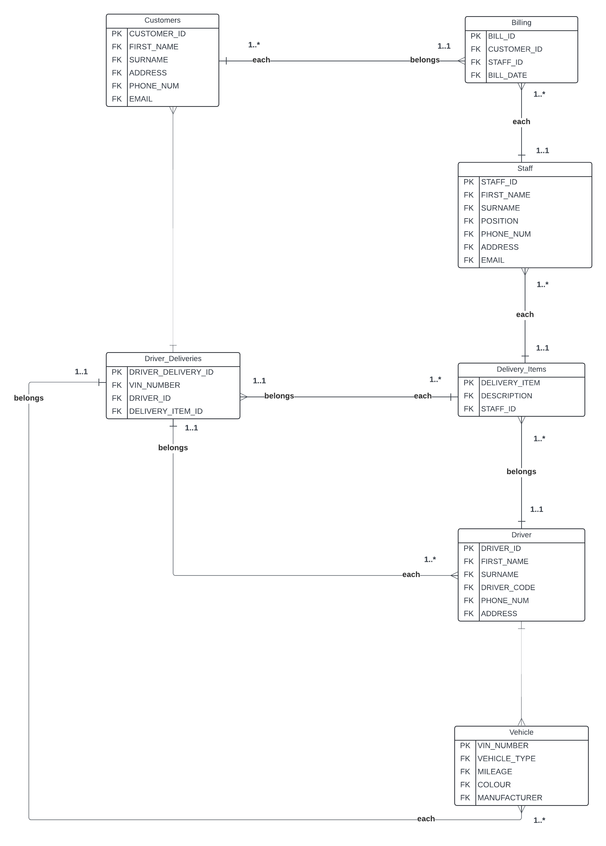

Question 2
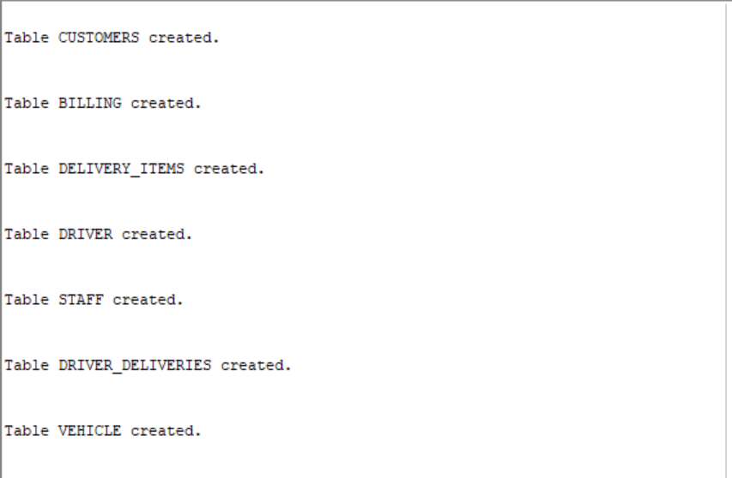
Tables Created:
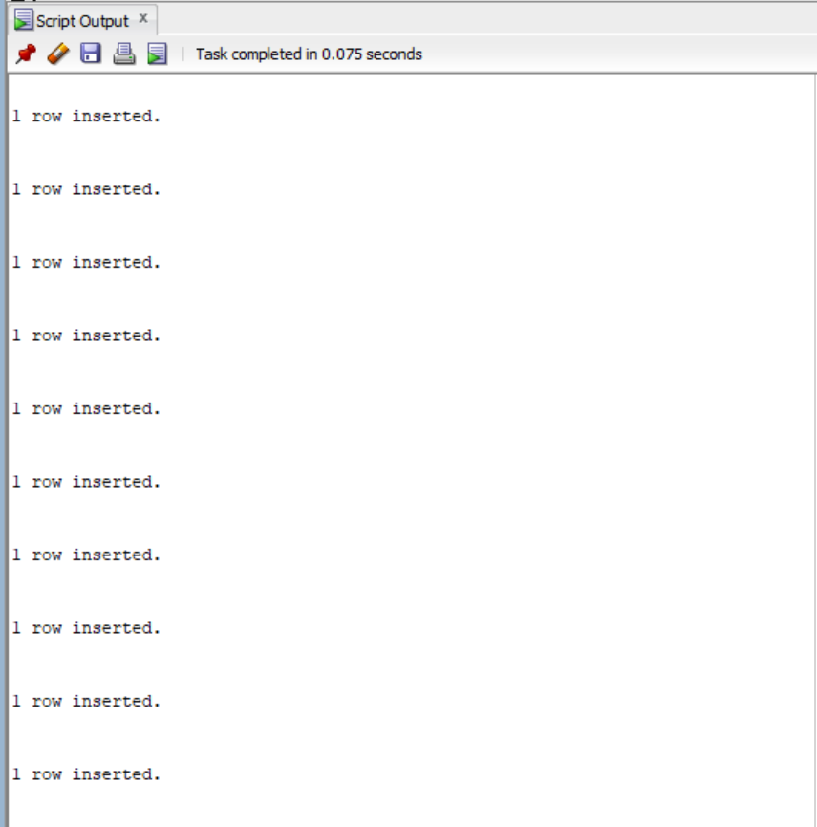
Tables Inserted:

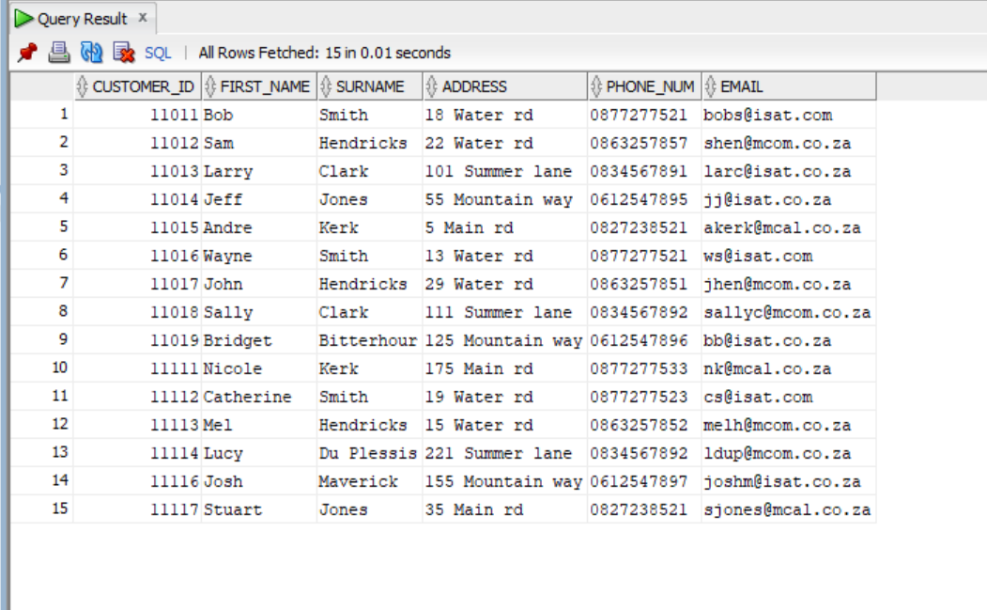
Customers:

Billing:
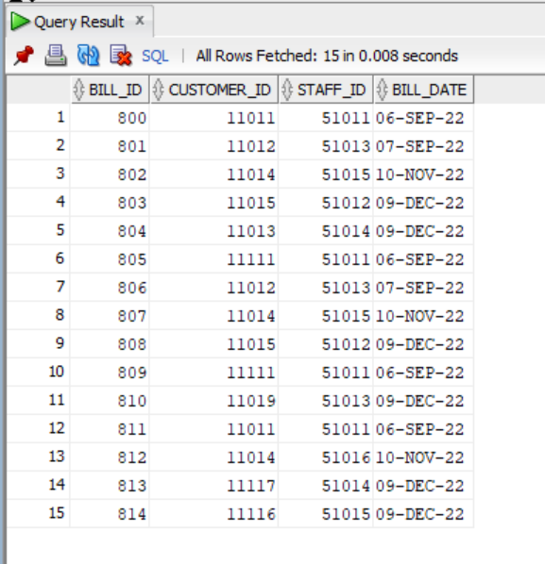

Delivery_Items:
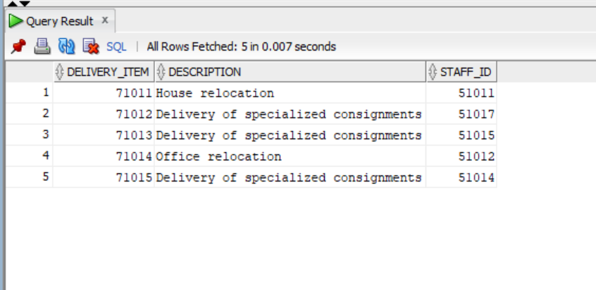

Driver:
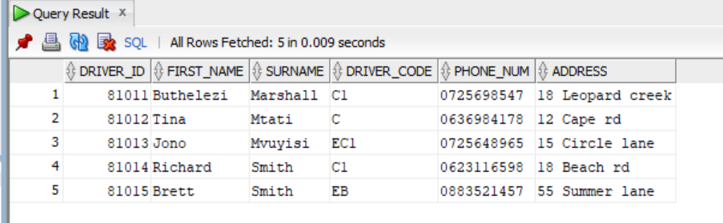
Driver_Deliveries:
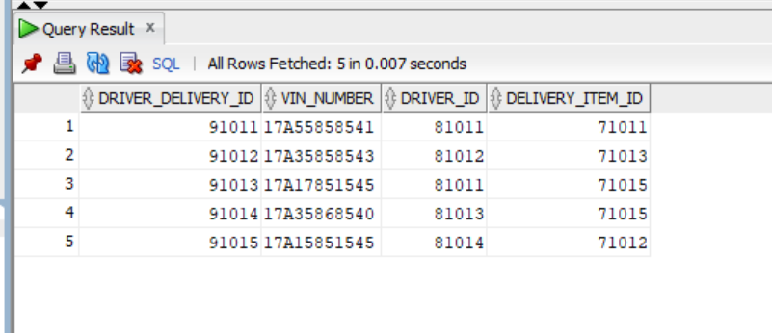
Staff:
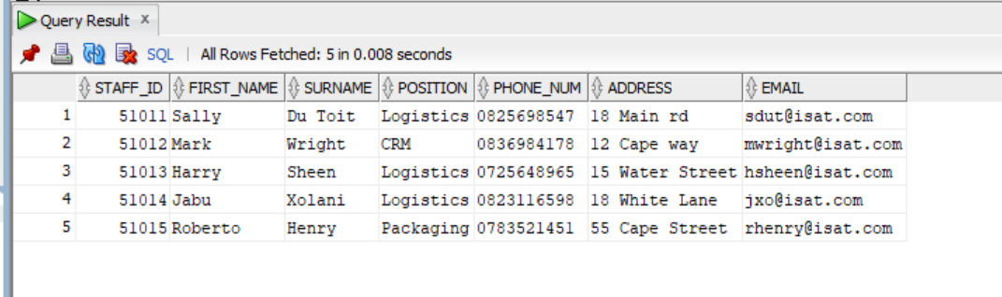

Vehicle:
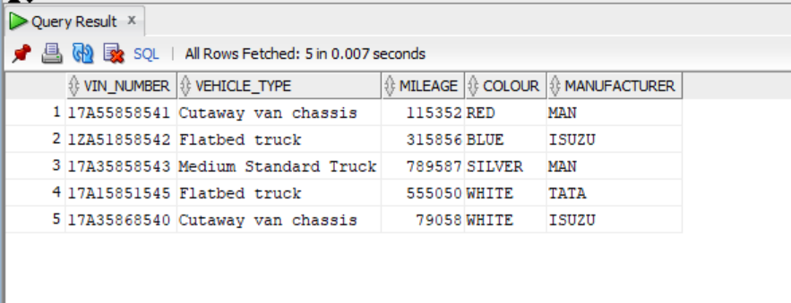

Question 3

Q.3.1
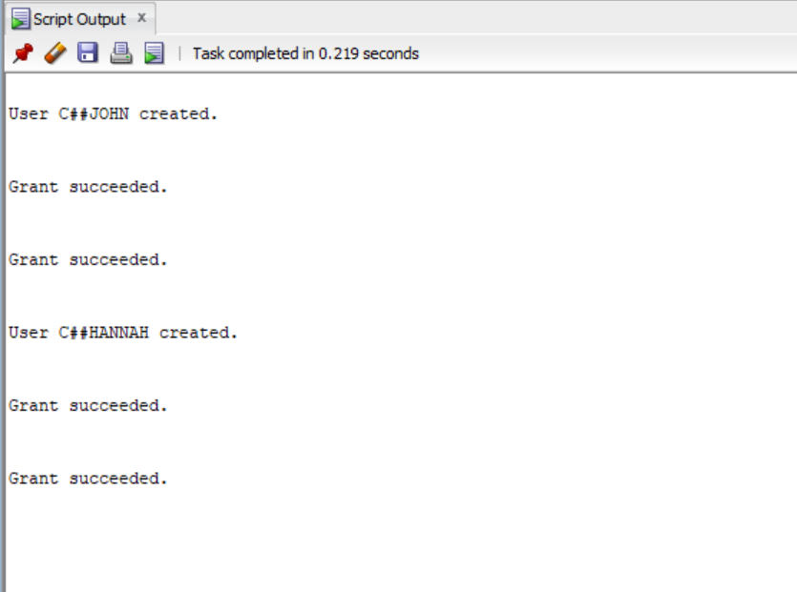

Q.3.2
- Conformity and Risk Control: Restricting access to pertinent data improves trust and lowers legal liabilities while assisting in risk management and ensuring adherence to safeguarding information laws.
- Responsibility and Execution Monitoring: Keeping tasks distinct makes it easier to pinpoint problems or potential areas for development. It also enables accurate performance tracking.
- Operational Efficiency: When roles are clearly defined, work is streamlined, and productivity is increased. Staff members concentrate on assigned tasks, and drivers only have access to the delivery information they need.
- Security of information and confidentiality: By limiting access, you can make sure that private data is safe from breaches and unauthorized use.

Question 4

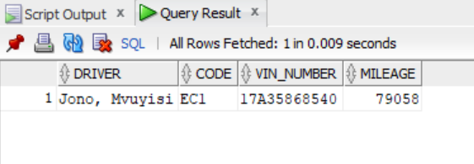
Q.4.1

Q.4.2
Flat File Database Model:
- Queries and data integrity can be challenging.
- Lacks connections between the records.
- Keeps information in a single file or table.
- High duplication of data and restricted scalability.
Relational Database Model:
- Makes use of SQL for effective and versatile querying.
- Arranges information into several connected tables.
- Decreases redundancy and works well with big datasets.
- Upholds the relationships and constraints that preserve data integrity.

I believe a relational model will better suit CHEETAH DELIVERIES of the following:
- SQL can be used by CHEETAH DELIVERIES to execute sophisticated queries and produce comprehensive reports on operational metrics, customer interactions, and delivery performance. Operational efficiency and sound decision-making are supported by this capability.
- Relational tables allow the business to handle and evaluate its operations more effectively by connecting related data. This methodical approach improves the accessibility and organization of data.
- SQL can be used by CHEETAH DELIVERIES to execute sophisticated queries and produce comprehensive reports on operational metrics, customer interactions, and delivery performance. Operational efficiency and sound decision-making are supported by this capability.

Question 5

Q.5.1
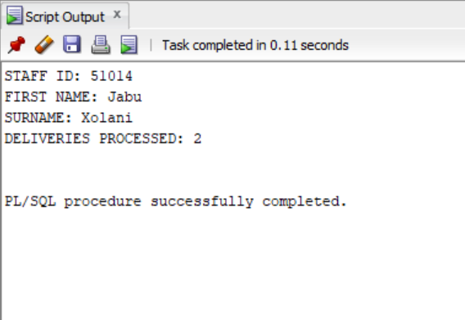

Q.5.2
- Declaration Section: In this section, data types defined by users that will be utilized in the PL/SQL block, such as variables, constants, and cursors, are declared.
- Execution Section: This section houses the primary code that carries out the operations and actions. It consists of statements that can be executed, like conditionals, loops, SQL queries, and assignments.
- Exception Handling Section: In this section, failures and exceptions that arise during the block's execution are handled. It offers a means of handling runtime errors and handling them gracefully.
(tutorialspoint, 2024).

Q.5.3

Q.5.3.1
How a View Operates:
- A CREATE VIEW statement is used to define a view. Its foundation is a SQL query that pulls information from one or more supporting tables.
- Users view the outcome of a view's SQL query as though it were a table of data when they query a view. Every time the view is accessed, data is dynamically retrieved from the underlying tables.
- Views can be used to restrict access to specific data rows or columns, present data in a particular format, or simplify complex queries.
Benefit: By offering an established query that conveys the data in a particular format or subset, a view makes data access easier for management. Managers are not required to write intricate SQL queries to obtain the reports they require. This lowers the possibility of mistakes and improves process usability.
(microsoft, 2024).

Q.5.3.2
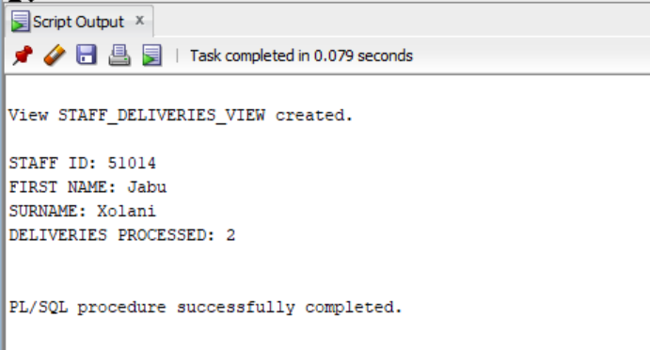

Question 6

Q.6.1

  - HOW? Oracle automatically creates implicit cursors upon the execution of a SQL statement, such as SELECT, INSERT, UPDATE, or DELETE. Simple queries that require no explicit authority over the cursor operations can benefit from the use of implicit cursors. More management of query processing is possible by utilizing the CURSOR keyword, which enables intricate calculations to be performed, repeating by means of a result set, and retrieving rows one at a time.
WHY Use Implicit Cursor? Implicit cursor attributes are perfect for simple operations requiring little coding effort because they enable fast and simple browsing of the current state of operations performed with DML lacking requiring explicit cursor handling.
  - HOW? Programmers can define explicit cursors explicitly by using the CURSOR keyword. This gives them greater authority over query processing, enabling them to execute complex logic, loop through an outcome set, and retrieve rows one at a time.
WHY Use Explicit Cursor? When processing a query result row-by-row is required, as in complicated business logic, or when retrieving multiple rows and performing iterative operations on them, explicit cursors are employed.
(tutorialspoint, 2024).

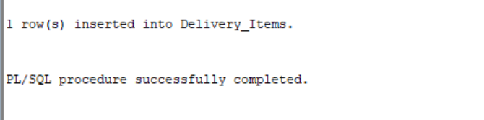

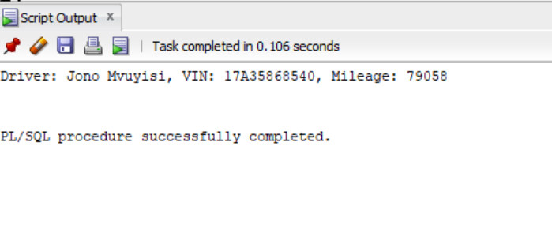

Q.6.2
When it comes to Cheetah Deliveries, a sequence can be especially helpful in creating unique identifiers for records like delivery IDs, customer IDs, or transaction IDs. This way, each new entry is automatically assigned a unique ID without the need for manual input or running the risk of duplication.
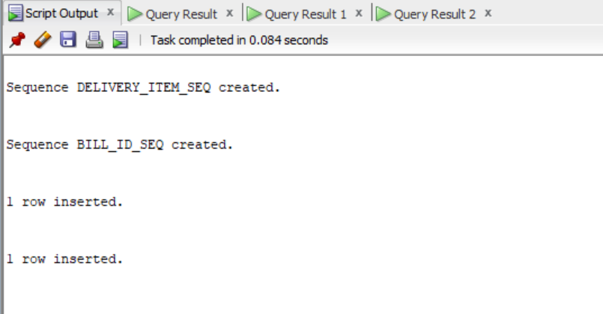

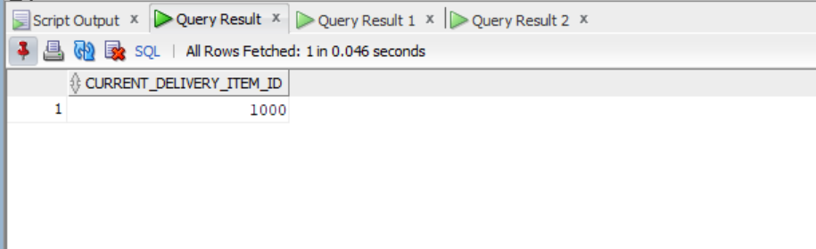
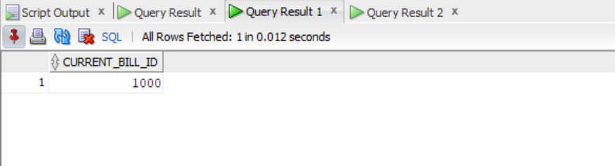

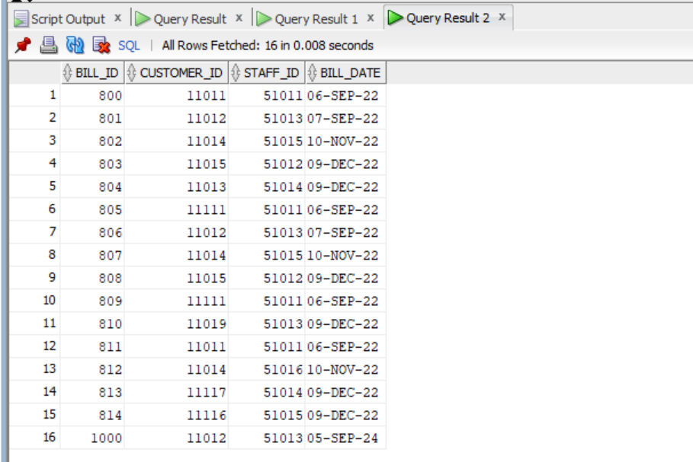

SQL Code
-- ST10393280 Daniel Luke James
-- Question 2

-- Create Tables

CREATE TABLE Customers (
CUSTOMER_ID NUMBER PRIMARY KEY,
FIRST_NAME VARCHAR2(50),
SURNAME VARCHAR2(50),
ADDRESS VARCHAR2(100),
PHONE_NUM VARCHAR2(20),
EMAIL VARCHAR2(100)
);

CREATE TABLE Billing (
BILL_ID NUMBER PRIMARY KEY,
CUSTOMER_ID NUMBER REFERENCES Customers(CUSTOMER_ID),
STAFF_ID NUMBER,
BILL_DATE DATE
);

CREATE TABLE Delivery_Items (
DELIVERY_ITEM NUMBER PRIMARY KEY,
DESCRIPTION VARCHAR2(100),
STAFF_ID NUMBER
);

CREATE TABLE Driver (
DRIVER_ID NUMBER PRIMARY KEY,
FIRST_NAME VARCHAR2(50),
SURNAME VARCHAR2(50),
DRIVER_CODE VARCHAR2(5),
PHONE_NUM VARCHAR2(20),
ADDRESS VARCHAR2(100)
);

CREATE TABLE Staff (
STAFF_ID NUMBER PRIMARY KEY,
FIRST_NAME VARCHAR2(50),
SURNAME VARCHAR2(50),
POSITION VARCHAR2(50),
PHONE_NUM VARCHAR2(20),
ADDRESS VARCHAR2(100),
EMAIL VARCHAR2(100)
);

CREATE TABLE Driver_Deliveries (
DRIVER_DELIVERY_ID NUMBER PRIMARY KEY,
VIN_NUMBER VARCHAR2(17),
DRIVER_ID NUMBER REFERENCES Driver(DRIVER_ID),
DELIVERY_ITEM_ID NUMBER REFERENCES Delivery_Items(DELIVERY_ITEM)
);

CREATE TABLE Vehicle (
VIN_NUMBER VARCHAR2(17) PRIMARY KEY,
VEHICLE_TYPE VARCHAR2(50),
MILEAGE NUMBER,
COLOUR VARCHAR2(20),
MANUFACTURER VARCHAR2(50)
);

-- Insert Data

-- Customers Table
-- Insert Data into Customers Table
INSERT INTO Customers (CUSTOMER_ID, FIRST_NAME, SURNAME, ADDRESS, PHONE_NUM, EMAIL) VALUES
(11011, 'Bob', 'Smith', '18 Water rd', '0877277521', 'bobs@isat.com');
INSERT INTO Customers (CUSTOMER_ID, FIRST_NAME, SURNAME, ADDRESS, PHONE_NUM, EMAIL) VALUES
(11012, 'Sam', 'Hendricks', '22 Water rd', '0863257857', 'shen@mcom.co.za');
INSERT INTO Customers (CUSTOMER_ID, FIRST_NAME, SURNAME, ADDRESS, PHONE_NUM, EMAIL) VALUES
(11013, 'Larry', 'Clark', '101 Summer lane', '0834567891', 'larc@isat.co.za');
INSERT INTO Customers (CUSTOMER_ID, FIRST_NAME, SURNAME, ADDRESS, PHONE_NUM, EMAIL) VALUES
(11014, 'Jeff', 'Jones', '55 Mountain way', '0612547895', 'jj@isat.co.za');
INSERT INTO Customers (CUSTOMER_ID, FIRST_NAME, SURNAME, ADDRESS, PHONE_NUM, EMAIL) VALUES
(11015, 'Andre', 'Kerk', '5 Main rd', '0827238521', 'akerk@mcal.co.za');
INSERT INTO Customers (CUSTOMER_ID, FIRST_NAME, SURNAME, ADDRESS, PHONE_NUM, EMAIL) VALUES
(11016, 'Wayne', 'Smith', '13 Water rd', '0877277521', 'ws@isat.com');
INSERT INTO Customers (CUSTOMER_ID, FIRST_NAME, SURNAME, ADDRESS, PHONE_NUM, EMAIL) VALUES
(11017, 'John', 'Hendricks', '29 Water rd', '0863257851', 'jhen@mcom.co.za');
INSERT INTO Customers (CUSTOMER_ID, FIRST_NAME, SURNAME, ADDRESS, PHONE_NUM, EMAIL) VALUES
(11018, 'Sally', 'Clark', '111 Summer lane', '0834567892', 'sallyc@mcom.co.za');
INSERT INTO Customers (CUSTOMER_ID, FIRST_NAME, SURNAME, ADDRESS, PHONE_NUM, EMAIL) VALUES
(11019, 'Bridget', 'Bitterhour', '125 Mountain way', '0612547896', 'bb@isat.co.za');
INSERT INTO Customers (CUSTOMER_ID, FIRST_NAME, SURNAME, ADDRESS, PHONE_NUM, EMAIL) VALUES
(11111, 'Nicole', 'Kerk', '175 Main rd', '0877277533', 'nk@mcal.co.za');
INSERT INTO Customers (CUSTOMER_ID, FIRST_NAME, SURNAME, ADDRESS, PHONE_NUM, EMAIL) VALUES
(11112, 'Catherine', 'Smith', '19 Water rd', '0877277523', 'cs@isat.com');
INSERT INTO Customers (CUSTOMER_ID, FIRST_NAME, SURNAME, ADDRESS, PHONE_NUM, EMAIL) VALUES
(11113, 'Mel', 'Hendricks', '15 Water rd', '0863257852', 'melh@mcom.co.za');
INSERT INTO Customers (CUSTOMER_ID, FIRST_NAME, SURNAME, ADDRESS, PHONE_NUM, EMAIL) VALUES
(11114, 'Lucy', 'Du Plessis', '221 Summer lane', '0834567892', 'ldup@mcom.co.za');
INSERT INTO Customers (CUSTOMER_ID, FIRST_NAME, SURNAME, ADDRESS, PHONE_NUM, EMAIL) VALUES
(11116, 'Josh', 'Maverick', '155 Mountain way', '0612547897', 'joshm@isat.co.za');
INSERT INTO Customers (CUSTOMER_ID, FIRST_NAME, SURNAME, ADDRESS, PHONE_NUM, EMAIL) VALUES
(11117, 'Stuart', 'Jones', '35 Main rd', '0827238521', 'sjones@mcal.co.za');

-- Billing Table
INSERT INTO Billing (BILL_ID, CUSTOMER_ID, STAFF_ID, BILL_DATE) VALUES
(800, 11011, 51011, TO_DATE('06-Sep-22', 'DD-Mon-YY'));
INSERT INTO Billing (BILL_ID, CUSTOMER_ID, STAFF_ID, BILL_DATE) VALUES
(801, 11012, 51013, TO_DATE('07-Sep-22', 'DD-Mon-YY'));
INSERT INTO Billing (BILL_ID, CUSTOMER_ID, STAFF_ID, BILL_DATE) VALUES
(802, 11014, 51015, TO_DATE('10-Nov-22', 'DD-Mon-YY'));
INSERT INTO Billing (BILL_ID, CUSTOMER_ID, STAFF_ID, BILL_DATE) VALUES
(803, 11015, 51012, TO_DATE('09-Dec-22', 'DD-Mon-YY'));
INSERT INTO Billing (BILL_ID, CUSTOMER_ID, STAFF_ID, BILL_DATE) VALUES
(804, 11013, 51014, TO_DATE('09-Dec-22', 'DD-Mon-YY'));
INSERT INTO Billing (BILL_ID, CUSTOMER_ID, STAFF_ID, BILL_DATE) VALUES
(805, 11111, 51011, TO_DATE('06-Sep-22', 'DD-Mon-YY'));
INSERT INTO Billing (BILL_ID, CUSTOMER_ID, STAFF_ID, BILL_DATE) VALUES
(806, 11012, 51013, TO_DATE('07-Sep-22', 'DD-Mon-YY'));
INSERT INTO Billing (BILL_ID, CUSTOMER_ID, STAFF_ID, BILL_DATE) VALUES
(807, 11014, 51015, TO_DATE('10-Nov-22', 'DD-Mon-YY'));
INSERT INTO Billing (BILL_ID, CUSTOMER_ID, STAFF_ID, BILL_DATE) VALUES
(808, 11015, 51012, TO_DATE('09-Dec-22', 'DD-Mon-YY'));
INSERT INTO Billing (BILL_ID, CUSTOMER_ID, STAFF_ID, BILL_DATE) VALUES
(809, 11111, 51011, TO_DATE('06-Sep-22', 'DD-Mon-YY'));
INSERT INTO Billing (BILL_ID, CUSTOMER_ID, STAFF_ID, BILL_DATE) VALUES
(810, 11019, 51013, TO_DATE('09-Dec-22', 'DD-Mon-YY'));
INSERT INTO Billing (BILL_ID, CUSTOMER_ID, STAFF_ID, BILL_DATE) VALUES
(811, 11011, 51011, TO_DATE('06-Sep-22', 'DD-Mon-YY'));
INSERT INTO Billing (BILL_ID, CUSTOMER_ID, STAFF_ID, BILL_DATE) VALUES
(812, 11014, 51016, TO_DATE('10-Nov-22', 'DD-Mon-YY'));
INSERT INTO Billing (BILL_ID, CUSTOMER_ID, STAFF_ID, BILL_DATE) VALUES
(813, 11117, 51014, TO_DATE('09-Dec-22', 'DD-Mon-YY'));
INSERT INTO Billing (BILL_ID, CUSTOMER_ID, STAFF_ID, BILL_DATE) VALUES
(814, 11116, 51015, TO_DATE('09-Dec-22', 'DD-Mon-YY'));

-- Delivery_Items Table
INSERT INTO Delivery_Items (DELIVERY_ITEM, DESCRIPTION, STAFF_ID) VALUES
(71011, 'House relocation', 51011);
INSERT INTO Delivery_Items (DELIVERY_ITEM, DESCRIPTION, STAFF_ID) VALUES
(71012, 'Delivery of specialized consignments', 51017);
INSERT INTO Delivery_Items (DELIVERY_ITEM, DESCRIPTION, STAFF_ID) VALUES
(71013, 'Delivery of specialized consignments', 51015);
INSERT INTO Delivery_Items (DELIVERY_ITEM, DESCRIPTION, STAFF_ID) VALUES
(71014, 'Office relocation', 51012);
INSERT INTO Delivery_Items (DELIVERY_ITEM, DESCRIPTION, STAFF_ID) VALUES
(71015, 'Delivery of specialized consignments', 51014);

-- Driver Table
INSERT INTO Driver (DRIVER_ID, FIRST_NAME, SURNAME, DRIVER_CODE, PHONE_NUM, ADDRESS) VALUES
(81011, 'Buthelezi', 'Marshall', 'C1', '0725698547', '18 Leopard creek');
INSERT INTO Driver (DRIVER_ID, FIRST_NAME, SURNAME, DRIVER_CODE, PHONE_NUM, ADDRESS) VALUES
(81012, 'Tina', 'Mtati', 'C', '0636984178', '12 Cape rd');
INSERT INTO Driver (DRIVER_ID, FIRST_NAME, SURNAME, DRIVER_CODE, PHONE_NUM, ADDRESS) VALUES
(81013, 'Jono', 'Mvuyisi', 'EC1', '0725648965', '15 Circle lane');
INSERT INTO Driver (DRIVER_ID, FIRST_NAME, SURNAME, DRIVER_CODE, PHONE_NUM, ADDRESS) VALUES
(81014, 'Richard', 'Smith', 'C1', '0623116598', '18 Beach rd');
INSERT INTO Driver (DRIVER_ID, FIRST_NAME, SURNAME, DRIVER_CODE, PHONE_NUM, ADDRESS) VALUES
(81015, 'Brett', 'Smith', 'EB', '0883521457', '55 Summer lane');

-- Driver_Deliveries Table
INSERT INTO Driver_Deliveries (DRIVER_DELIVERY_ID, VIN_NUMBER, DRIVER_ID, DELIVERY_ITEM_ID) VALUES
(91011, '17A55858541', 81011, 71011);
INSERT INTO Driver_Deliveries (DRIVER_DELIVERY_ID, VIN_NUMBER, DRIVER_ID, DELIVERY_ITEM_ID) VALUES
(91012, '17A35858543', 81012, 71013);
INSERT INTO Driver_Deliveries (DRIVER_DELIVERY_ID, VIN_NUMBER, DRIVER_ID, DELIVERY_ITEM_ID) VALUES
(91013, '17A17851545', 81011, 71015);
INSERT INTO Driver_Deliveries (DRIVER_DELIVERY_ID, VIN_NUMBER, DRIVER_ID, DELIVERY_ITEM_ID) VALUES
(91014, '17A35868540', 81013, 71015);
INSERT INTO Driver_Deliveries (DRIVER_DELIVERY_ID, VIN_NUMBER, DRIVER_ID, DELIVERY_ITEM_ID) VALUES
(91015, '17A15851545', 81014, 71012);

-- Staff Table
INSERT INTO Staff (STAFF_ID, FIRST_NAME, SURNAME, POSITION, PHONE_NUM, ADDRESS, EMAIL) VALUES
(51011, 'Sally', 'Du Toit', 'Logistics', '0825698547', '18 Main rd', 'sdut@isat.com');
INSERT INTO Staff (STAFF_ID, FIRST_NAME, SURNAME, POSITION, PHONE_NUM, ADDRESS, EMAIL) VALUES
(51012, 'Mark', 'Wright', 'CRM', '0836984178', '12 Cape way', 'mwright@isat.com');
INSERT INTO Staff (STAFF_ID, FIRST_NAME, SURNAME, POSITION, PHONE_NUM, ADDRESS, EMAIL) VALUES
(51013, 'Harry', 'Sheen', 'Logistics', '0725648965', '15 Water Street', 'hsheen@isat.com');
INSERT INTO Staff (STAFF_ID, FIRST_NAME, SURNAME, POSITION, PHONE_NUM, ADDRESS, EMAIL) VALUES
(51014, 'Jabu', 'Xolani', 'Logistics', '0823116598', '18 White Lane', 'jxo@isat.com');
INSERT INTO Staff (STAFF_ID, FIRST_NAME, SURNAME, POSITION, PHONE_NUM, ADDRESS, EMAIL) VALUES
(51015, 'Roberto', 'Henry', 'Packaging', '0783521451', '55 Cape Street', 'rhenry@isat.com');

-- Vehicle Table
INSERT INTO Vehicle (VIN_NUMBER, VEHICLE_TYPE, MILEAGE, COLOUR, MANUFACTURER) VALUES
('17A55858541', 'Cutaway van chassis', 115352, 'RED', 'MAN');
INSERT INTO Vehicle (VIN_NUMBER, VEHICLE_TYPE, MILEAGE, COLOUR, MANUFACTURER) VALUES
('1ZA51858542', 'Flatbed truck', 315856, 'BLUE', 'ISUZU');
INSERT INTO Vehicle (VIN_NUMBER, VEHICLE_TYPE, MILEAGE, COLOUR, MANUFACTURER) VALUES
('17A35858543', 'Medium Standard Truck', 789587, 'SILVER', 'MAN');
INSERT INTO Vehicle (VIN_NUMBER, VEHICLE_TYPE, MILEAGE, COLOUR, MANUFACTURER) VALUES
('17A15851545', 'Flatbed truck', 555050, 'WHITE', 'TATA');
INSERT INTO Vehicle (VIN_NUMBER, VEHICLE_TYPE, MILEAGE, COLOUR, MANUFACTURER) VALUES
('17A35868540', 'Cutaway van chassis', 79058, 'WHITE', 'ISUZU');

-- View each tables data
SELECT * FROM Customers;
SELECT * FROM Billing;
SELECT * FROM Delivery_Items;
SELECT * FROM Driver;
SELECT * FROM Driver_Deliveries;
SELECT * FROM Staff;
SELECT * FROM Vehicle;

-- Question 3.1
CREATE USER C##John IDENTIFIED BY Johnch2024;
GRANT CONNECT TO C##John;
GRANT SELECT ANY TABLE TO C##John;

CREATE USER C##Hannah IDENTIFIED BY Hannahch2024;
GRANT CONNECT TO C##Hannah;
GRANT INSERT ANY TABLE TO C##Hannah;

-- Question 4.1
SELECT
D.FIRST_NAME || ', ' || D.SURNAME AS DRIVER,
D.DRIVER_CODE AS CODE,
V.VIN_NUMBER,
V.MILEAGE
FROM
Driver_Deliveries DD
JOIN
Driver D ON DD.DRIVER_ID = D.DRIVER_ID
JOIN
Vehicle V ON DD.VIN_NUMBER = V.VIN_NUMBER
WHERE
V.MILEAGE < 80000;

-- Question 5.1
-- I assume there is an error with the assignment. Delivery_Items table only has one occurrence for each Staff_ID.
-- I inserted another line into the Delivery_Items table, so there is two occurrences for a Staff_ID, being '51014'.
INSERT INTO Delivery_Items (DELIVERY_ITEM, DESCRIPTION, STAFF_ID) VALUES
(71016, 'Test Item', 51014);

-- PL/SQL procedure
SET SERVEROUTPUT ON;

DECLARE
v_staff_id Staff.STAFF_ID%TYPE;
v_first_name Staff.FIRST_NAME%TYPE;
v_surname Staff.SURNAME%TYPE;
v_deliveries_processed NUMBER;

BEGIN
SELECT STAFF_ID, FIRST_NAME, SURNAME, DELIVERIES_COUNT
INTO v_staff_id, v_first_name, v_surname, v_deliveries_processed
FROM (
SELECT S.STAFF_ID, S.FIRST_NAME, S.SURNAME, COUNT(D.DELIVERY_ITEM) AS DELIVERIES_COUNT
FROM Staff S
JOIN Delivery_Items D ON S.STAFF_ID = D.STAFF_ID
GROUP BY S.STAFF_ID, S.FIRST_NAME, S.SURNAME
ORDER BY COUNT(D.DELIVERY_ITEM) DESC
)
WHERE ROWNUM = 1;

-- Display
DBMS_OUTPUT.PUT_LINE('STAFF ID: ' || v_staff_id);
DBMS_OUTPUT.PUT_LINE('FIRST NAME: ' || v_first_name);
DBMS_OUTPUT.PUT_LINE('SURNAME: ' || v_surname);
DBMS_OUTPUT.PUT_LINE('DELIVERIES PROCESSED: ' || v_deliveries_processed);

END;
/

-- Question 5.3.2
-- Creating the View
CREATE OR REPLACE VIEW STAFF_DELIVERIES_VIEW AS
SELECT
S.STAFF_ID,
S.FIRST_NAME,
S.SURNAME,
COUNT(D.DELIVERY_ITEM) AS DELIVERIES_COUNT
FROM
Staff S
JOIN
Delivery_Items D
ON
S.STAFF_ID = D.STAFF_ID
GROUP BY
S.STAFF_ID,
S.FIRST_NAME,
S.SURNAME;

-- Modified Code
SET SERVEROUTPUT ON;

DECLARE
v_staff_id Staff.STAFF_ID%TYPE;
v_first_name Staff.FIRST_NAME%TYPE;
v_surname Staff.SURNAME%TYPE;
v_deliveries_processed NUMBER;

BEGIN
SELECT STAFF_ID, FIRST_NAME, SURNAME, DELIVERIES_COUNT
INTO v_staff_id, v_first_name, v_surname, v_deliveries_processed
FROM (
-- Ordered by Highest Count
SELECT STAFF_ID, FIRST_NAME, SURNAME, DELIVERIES_COUNT
FROM STAFF_DELIVERIES_VIEW
ORDER BY DELIVERIES_COUNT DESC
)
-- Select Highest Record
WHERE ROWNUM = 1;

-- Display
DBMS_OUTPUT.PUT_LINE('STAFF ID: ' || v_staff_id);
DBMS_OUTPUT.PUT_LINE('FIRST NAME: ' || v_first_name);
DBMS_OUTPUT.PUT_LINE('SURNAME: ' || v_surname);
DBMS_OUTPUT.PUT_LINE('DELIVERIES PROCESSED: ' || v_deliveries_processed);

END;
/

-- Question 6.2
-- Example Of Implicit Cursor Attribute
BEGIN
-- Insert a new delivery item
INSERT INTO Delivery_Items (DELIVERY_ITEM, DESCRIPTION, STAFF_ID)
VALUES (71018, 'Urgent Parcel Delivery', 51013);

-- Check if successful
IF SQL%ROWCOUNT > 0 THEN
DBMS_OUTPUT.PUT_LINE(SQL%ROWCOUNT || ' row(s) inserted into Delivery_Items.');
ELSE
DBMS_OUTPUT.PUT_LINE('No rows were inserted.');
END IF;
END;
/

-- Example of Explicit Cursor Attribute
DECLARE
CURSOR driver_cursor IS
SELECT D.FIRST_NAME, D.SURNAME, V.VIN_NUMBER, V.MILEAGE
FROM Driver_Deliveries DD
JOIN Driver D ON DD.DRIVER_ID = D.DRIVER_ID
JOIN Vehicle V ON DD.VIN_NUMBER = V.VIN_NUMBER
WHERE V.MILEAGE < 80000;

v_first_name Driver.FIRST_NAME%TYPE;
v_surname Driver.SURNAME%TYPE;
v_vin_number Vehicle.VIN_NUMBER%TYPE;
v_mileage Vehicle.MILEAGE%TYPE;
BEGIN
OPEN driver_cursor;

LOOP
FETCH driver_cursor INTO v_first_name, v_surname, v_vin_number, v_mileage;

EXIT WHEN driver_cursor%NOTFOUND;

DBMS_OUTPUT.PUT_LINE('Driver: ' || v_first_name || ' ' || v_surname ||
', VIN: ' || v_vin_number ||
', Mileage: ' || v_mileage);
END LOOP;

CLOSE driver_cursor;
END;
/

-- Question 6.2
-- Create a sequences
CREATE SEQUENCE DELIVERY_ITEM_SEQ
START WITH 1000
INCREMENT BY 1
MINVALUE 1000
MAXVALUE 9999
NOCYCLE
CACHE 20;

CREATE SEQUENCE BILL_ID_SEQ
START WITH 1000
INCREMENT BY 1
MINVALUE 1000
MAXVALUE 9999
NOCYCLE
CACHE 20;

-- Example (Test Data)
INSERT INTO Delivery_Items (DELIVERY_ITEM, DESCRIPTION, STAFF_ID)
VALUES (DELIVERY_ITEM_SEQ.NEXTVAL, 'Urgent Parcel Delivery', 51013);

INSERT INTO Billing (BILL_ID, CUSTOMER_ID, STAFF_ID, BILL_DATE)
VALUES (BILL_ID_SEQ.NEXTVAL, 11012, 51013, SYSDATE);

-- Display
SELECT DELIVERY_ITEM_SEQ.CURRVAL AS current_delivery_item_id FROM dual;
SELECT BILL_ID_SEQ.CURRVAL AS current_bill_id FROM dual;

-- View Data
SELECT * FROM Delivery_Items;
SELECT * FROM Billing;

Reference List
- tutorialspoint. 2024. PL/SQL - Basic Syntax.
[Online] Available at:
https://www.tutorialspoint.com/plsql/plsql_basic_syntax.htm
[Accessed on 1 September 2024].
- microsoft.2024. Views. 19 July 2024.
[Online] Available at:
https://learn.microsoft.com/en-us/sql/relational-databases/views/views?view=sql-server-ver16
[Accessed on 1 September 2024].
- tutorialspoint. 2024. PL/SQL - Cursors.
[Online] Available at:
https://www.tutorialspoint.com/plsql/plsql_cursors.htm
[Accessed on 2 September 2024].

